Linear Statistical Models
Basic Computations with Python and SciPy
Nicholas Bennett
nick@nickbenn.com

Copyright and License Information

Copyright © 2018 by Nicholas Bennett. All rights reserved.
“Linear Statistical Models: Basic Computations with Python and SciPy” by Nicholas Bennett is licensed under a Creative Commons Attribution-ShareAlike 4.0 International License. Permissions beyond the scope of this license may be available; for more information, contact nick@nickbenn.com.
Redistribution and use of accompanying program code in source and binary forms, with or without modification, are permitted provided that the following conditions are met:
- Redistributions of source code must retain the above copyright notice, this list of conditions and the following disclaimer.
- Redistributions in binary form must reproduce the above copyright notice, this list of conditions and the following disclaimer in the documentation and/or other materials provided with the distribution.
This software is provided by Nicholas Bennett "as is" and any express or implied warranties, including, but not limited to, the implied warranties of merchantability and fitness for a particular purpose are disclaimed. In no event shall Nicholas Bennett be liable for any direct, indirect, incidental, special, exemplary, or consequential damages (including, but not limited to, procurement of substitute goods or services; loss of use, data, or profits; or business interruption) however caused and on any theory of liability, whether in contract, strict liability, or tort (including negligence or otherwise) arising in any way out of the use of this software, even if advised of the possibility of such damage.

Linear Models
Much of the following is a quick review of the relevant sections from the companion document, “Mathematical Models & Linear Statistical Models: Basic Concepts & Computations”. If you have not read that document, we recommend you do so now.

Definition
One of the simplest statistical models is applicable to a wide range of problems. In the linear model, a dependent variable is expressed as a linear combination of independent variables and an error term:
, | (1)
where

Formally, the independent variables are assumed to be continuous over real value ranges; in practice, this condition is often relaxed to allow for integral or other discrete numeric values.

Simple Linear Models
In a simple linear model, there's only one independent variable and one dependent variable, so (1) becomes
. | (2)
This is often written as
. | (3)
As a rule, we don’t know the values of and , but must estimate them. We denote our estimates of these two parameters by a and b, respectively; the formula for our estimated line is
. | (4)
In (4), represents the actual values of the independent variable, while represents the fitted (estimated) values of the dependent variable .
As you've probably figured out already, a simple linear model is easy to show graphically, along with the actual data. It's essentially a straight line through the data points, fitting them as closely as possible—though we haven't yet said what “as closely as possible” really means.

Finding the Best Fit via Linear Regression
In linear regression, the values we choose for a and b are those that minimize the sum of squared differences between the fitted and actual values of . This sum is called the sum of squared errors (SSE), and is given by
. | (5)
Using calculus, we find that for a simple linear model, a and b can be computed as
(6)

R²: The Coefficient of Determination
When fitting a statistical model (not necessarily linear) to actual data, we often compute the coefficient of determination, denoted as R², as an indicator of how closely the model fits the data. We compute R² as
, | (7)
where SSR (sum of squares of regression) and SST (sum of squares, total) are computed as follows:
(8)
(9)
SST, SSR, and SSE (see (5)) can also be expressed in terms of each other:
. | (10)
The larger that SSR is in relation to SST, the more that the change in the dependent variable is explained by the model. More specifically, we can interpret R² as the fraction of the variation in the dependent variable that's determined or explained by the model.

Implementation of Simple Least-Squares Linear Regression

General Features and Components
To tackle the cricket chirp problem described in “Mathematical Models & Linear Statistical Models: Basic Concepts & Computations” (using data in Appendix A, illustrated in Figure 3), we'll use the Python programming language. The code that accompanies this document is functional but incomplete: it runs as-is, but it doesn’t perform the simple linear least-squares regression analysis; for that, we’ll have to add to the code.
An important feature that's already provided in the code, but that we won't be examining, is the capability to read a simple table of values from a comma-separated-values (CSV) text file.
While graphical output isn't strictly necessary for regression analysis, it can be very useful in exploratory analysis and in presenting regression results. Thus, the provided Python code uses the Matplotlib open source library to display the input data and the regression results [3].

Development Tools
The provided Python code requires Python 2.7+ or Python 3.4+ with Matplotlib 2.x, or Python 3.5+ with Matplotlib 3.x. It can be edited and run with virtually any Python development and runtime environment that satisfies these version constraints.

Computational Methods
There are a number of different ways to compute measures and estimates used in descriptive and inferential statistics, including those for least-squares regression. For example, the following formulas for a and b are mathematically equivalent to (6).
(11)
It's easy to think of computers as perfect calculators, but the reality is different—especially when we put them to the task of numerical analysis with floating-point values:
- Some methods are efficient, but potentially unstable—i.e. in some cases, the calculations magnify the inaccuracy inherent in the standard computer representations of most floating-point values.
- Some methods, like (11), are more stable, but less efficient.
- Still other methods are relatively stable and efficient, but not as easy to understand or implement.
The method for computing a and b used in (6) has potential scale and stability problems; on the other hand, it's easily understood and implemented, and it has generally good performance. For that reason, we’ll use this method in the first set of additions to our Python code.

Programming Concepts

Intrinsic data structures
Like virtually all programming languages, Python has certain types of data that are intrinsic—that is, they're recognized and supported natively by compilers or interpreters of the Python language. Some of these types are scalar, holding a single value, and some hold sequences of multiple values. The basic Python intrinsic sequence types (which are in fact called sequences) include strings of characters (str and unicode), arrays of single bytes (bytearray), and lists and tuples, which are sequences of objects. A list is mutable—that is, items can be added to and removed from a list—while a tuple is immutable. In Python, a programmer doesn't really know or care how the members of a tuple or list are stored in memory, and whether they're contiguous or not; the focus tends to be less on scanning across the elements in a step-by-step fashion, and more on the high-level operations that are applied to the entire list at once, or to a subset satisfying some condition.

Line and statement structure
In Python, a program statement is ended by a line break, unless that line break occurs inside a set of parentheses or brackets, or the line ends with the continuation character (the backslash). This means that care must be taken when breaking a line for readability purposes. (A semicolon may also be used to end a Python statement, but this is usually done only when including multiple statements on the same line.)
In Python, flow control statements (other than return and break), as well as class and def statements (def marks the start of a function or method definition) are called clauses; a clause is terminated by a colon, and must be followed by a suite of statements. A suite consists of one or more statements that are controlled by the flow control or definition clause that precedes it. If the suite contains more than one statement, those statements must be indented below the controlling clause; a suite with one statement may follow the clause on the same line. If no statements at all are wanted in a suite (this often happens when first writing the code for a clause), the pass statement is used.
The rules for indentation of suites result in one of the most distinctive characteristics of Python code: rather than simply being a matter of style, indentation is syntactically significant. Further, inconsistent indentation (including mixing tab characters and space characters) can produce syntax errors that prevent a Python program from running. For programmers who aren't used to Python syntax, this can be inconvenient, at least at the start. But there's a benefit to these rules: in syntactically correct Python code, the visual structure of the code usually matches the logical structure quite closely.

Conditional execution of statements
Like virtually all programming languages, Python includes statements for testing a condition, then following one path of execution if the condition is true, and (optionally) following another path if the condition is false. The keyword that introduces these conditional statements in Python is if; zero or more elif (else-if) clauses may follow the if clause. After any elif clauses, there may be an else clause.
Let's look at a few simple code fragments (Listing 1) showing conditional statements. Notice that the # character starts a comment that continues until the end of the line. Python also supports a special comment format for code documentation (which we’ll see in the code we modify), but that's not shown here. Also, note the “lower snake case” convention used for multi-word identifiers (variable or function names). Finally, note that do_something(), do_something_else(), etc. are simply placeholders for actual functions—they don't actually correspond to anything in the example listing, or to built-in functions in either language.
# Execute a suite if the value of some variable x is less than or equal to
# the value of another variable y; otherwise, skip over the suite.
if x <= y:
do_something()

# Execute a suite if the value of some variable x is less than or equal to
# the value of another variable y; otherwise, execute a second suite.
if x <= y:
do_something()
else:
do_something_else()

# Execute a suite if the value of some variable x is less than or equal to
# the value of another variable y; otherwise, execute a second suite if x is
# x is greater than z; otherwise, execute a third block.
if x <= y:
do_something()
elif x > z:
do_another_thing()
else:
do_something_else()
Listing 1: Conditionals in Python

Explicit and implicit iteration
Python has multiple mechanisms for iterating over a sequence. The for and while statements are used for explicit iteration; additionally, there are implicit iteration constructs, such as the map function and comprehensions, that apply an operation to every item in a sequence, and return a new sequence. See Listing 2 for simple examples of both explicit and implicit iteration.
# Repeat a suite for each value of i from 0 to len(some_list)—1
# (inclusive), incrementing i after each iteration.
for i in range(len(some_list)):
do_something()

# Repeat a suite for each element of another_list.
for j in another_list:
do_something()

# Repeat a suite as long as an already declared variable k is less than
# limit.
while k < limit:
do_something()

# Use list comprehension to construct dest_list based on the elements of
# source_list, where each element of dest_list is the square of the
# corresponding value from source_list.
dest_list = [x ** 2 for x in source_list]

# Use list comprehension to construct dest_list based on a subset of the
# elements of source_list: each element of dest_list is the doubled value
# of the corresponding value from source_list, but only for the positive
# values in source_list.
dest_list = [2 * x for x in source_list if x > 0]
Listing 2: Explicit and implicit iteration in Python

References to members of an object
Python supports the definition of classes for object-oriented programming. A class is simply a data structure definition, along with definitions of the behaviors associated with that data; an object is a variable based on a class definition. Classes often correspond to the types of physical or logical real-world objects that are represented in the program. A general introduction to object-oriented programming is beyond the scope of this document, so we'll focus just on those aspects that are most relevant to our immediate needs.
Note that Python doesn't insist on an object-oriented approach; this often allows for simpler code in cases where new classes aren't needed—but when an object-oriented approach is employed, Python code in class definitions can be a bit unintuitive. In particular, the use of self to refer to the current object instance is not optional (as it is in some languages): it is required within methods when referring to data and other methods of the object, and self must be the first parameter of each method defined in the class.

Running the Initial Program

Python program (chirps.py)
Using your chosen Python development tools, locate and open the chirps.py and simple_linear.py files. The first of these is the main Python script that you'll run to execute the linear regression, and the second will perform the mathematical calculations.
Before we make any additions to the code, let's see what it does so far. Begin by running the chirps.py script in your Python development environment (or from the command line); you should see a window displaying the cricket chirps vs. temperature data (Figure 1).
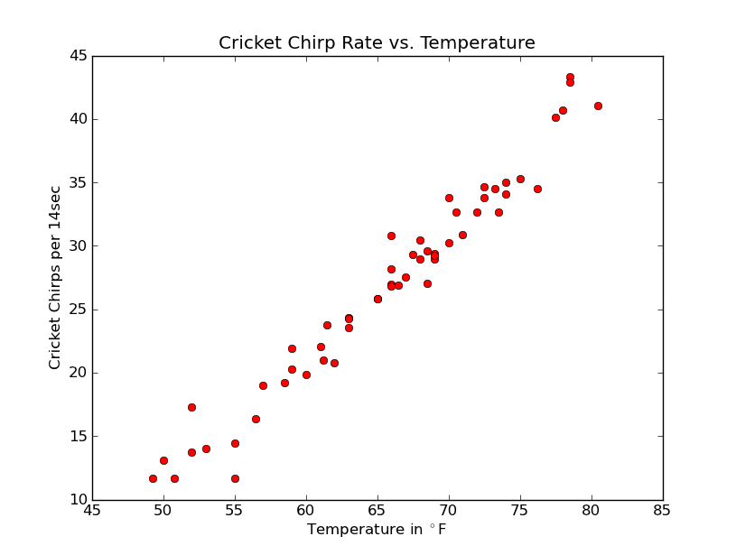Figure 1: Initial Python program display
Let's examine what's happening at a high level, and follow along with the code itself (Outline 1).
- __main__ script [chirps.py]
Main program script, which invokes functions in chirps.py and the other files.
  - load function [chirps.py]
    - TableFileParser.__init__ constructor [parser_util.py]
Opens the specified data file, and reads it into memory as a list of lines, where each line is a list of data values.
    - TableFileParser.floats method [parser_util.py]
Returns the previously read data values as floating-point numbers.
  - SimpleLinear.__init__ constructor [simple_linear.py]
Copies the provided data to self._x and self._y, and stores the number of data points in self._n, in preparation for linear regression.
  - SimpleLinear.regress method [simple_linear.py]
    - SimpleLinear._compute_sums method [simple_linear.py]
Currently, this method doesn't do anything (notice the pass statement) Shortly, we'll add the code to calculate , , , , and , and store those values in self._sum_x, self._sum_y, self._sum_xy, self._sum_x2, and self._sum_y2, respectively.
    - SimpleLinear._estimate_parameters method [simple_linear.py]
We'll add code to this method to use the values computed by SimpleLinear._compute_sums to calculate the estimated intercept and slope of the regression line, and store those in self._intercept and self._slope (respectively).
    - SimpleLinear._measure_fit method [simple_linear.py]
Here, we'll add the code to compute SST, the fitted points on the line, and SSE, and use those values to calculate R², then store that value in self._r2.
  - plot function [chirps.py]
This function invokes methods in the Matplotlib library to render the scatterplot. Notice that this function has an if clause: the suite for that clause (which displays the regression line and equation) will only be executed if
model.r2 >= 0 (model is a variable based on the SimpleLinear class). Before we add the code for the SimpleLinear._compute_sums, SimpleLinear._estimate_parameters, and SimpleLinear._measure_fit methods, what is the self._r2 value of a SimpleLinear object?
Outline 1: Python program structure

Implementing Linear Regression

Computing the sums
In computing , , , , and , the fact that the X and Y values are stored in Python sequences (specifically, in tuples) makes our job relatively easy. For one thing, Python includes a sum function that computes the sum of a sequence, without us having to write code to iterate over the sequence. Another useful function is map, which transforms 1 or more input sequences into an output sequence; this is ideal for constructing a sequence containing the products of corresponding terms in 2 different sequences, so that we can then use sum on the resulting sequence. Finally, for computing the sum of squared items in a sequence, we can use either the map function or list comprehension to create a sequence of squared values, and then apply the sum function to that.
The code below shows the _compute_sums method of the SimpleLinear class. The code that we need to keep from the initial version is in gray, normal-weight type; the code we need to add is in dark bold type. One line of code that we should delete is shown in strike-through type.
def _compute_sums(self):
"""Computes intermediate sums for regression."""
pass
self._sum_x = sum(self._x)
self._sum_y = sum(self._y)
self._sum_xy = sum(map(lambda x, y: x * y, self._x, self._y))
self._sum_x2 = sum(x * x for x in self._x)
self._sum_y2 = sum(y * y for y in self._y)
Listing 3: SimpleLinear._compute_sums method
(Be sure you still have a blank line after the added code, before the _estimate_parameters method that follows it. Also, watch out for underscore characters, which can be hard to see.)
The first 2 lines we added are pretty straightforward: in each, we’re simply using the sum function to add up all of the items in a sequence. The next line, however, is a little less obvious: the map function expects at least 2 arguments: the first is a lambda, or anonymous function, which states how the items in the sequences specified in the remaining arguments should be transformed to produce new values. In this case, lambda x, y: x * y specifies that there will be 2 sequences processed as inputs (based on the number of parameters declared for the lambda, between the lambda keyword and the colon character), and that each value in the resulting sequence will be produced by multiplying the corresponding values from the input sequences together.
The last 2 lines we added use comprehension, in which we specify an expression (e.g. x * x) to be applied and evaluated for every item in an existing sequence, to produce a new sequence. This may sound very similar to the operation of the map function, and it is: In many cases, comprehension can be seen as a simplified way of expressing an operation that we might otherwise express with the map and/or filter functions.
Finally, note that we’re assigning each of the computed sums to the relevant field of the current SimpleLinear object (self).
Save your changes and run chirps.py again. Fix any syntax errors reported by Python.

Estimating the Regression Parameters
Now that we have the component sums, we can use them to compute a and b. To do this, let’s add a few lines of code to the SimpleLinear._estimate_parameters method:
def _estimate_parameters(self):
"""Computes intercept and slope from sums."""
pass
self._intercept = (
(self._sum_x2 * self._sum_y - self._sum_x * self._sum_xy)
/ (self._n * self._sum_x2 - self._sum_x * self._sum_x))
self._slope = (
(self._n * self._sum_xy - self._sum_x * self._sum_y)
/ (self._n * self._sum_x2 - self._sum_x * self._sum_x))
Listing 4: SimpleLinear._estimate_parameters method
We’re only adding 2 statements this time—but because each is fairly long, and includes several terms in its calculations, together they extend over 6 lines. Be careful to keep your parentheses balanced (also, notice that Python allows a statement to extend over multiple lines, even without a line continuation character, if there’s an open set of parentheses, brackets, or braces).
The expressions for the values computed and assigned to _intercept and _slope are taken directly from the expressions for a and b (respectively) in (6).
Once again, you can check for some errors in the code by saving your changes and running chirps.py. There won’t be any visible change to the plotted output (since we haven’t yet computed R²), but the new code will be parsed and executed, allowing Python to catch syntax errors.

Computing Ŷ and R²
Now that we have our regression coefficients, a and b, we can compute the fitted values, Ŷ; from the latter, we can then compute the coefficient of determination, R². This will be performed by code in the _measure_fit method of of the SimpleLinear class:
def _measure_fit(self):
"""Computes fitted values and goodness-of-fit statistic(s)."""
pass
sst = self._sum_y2 - self._sum_y * self._sum_y / self._n;
fitted = [self._intercept + self._slope * x for x in self._x]
sse = sum(map(lambda y, y_hat: (y - y_hat) ** 2, self._y, fitted))
self._r2 = 1 - sse / sst
Listing 5: SimpleLinear._measure_fit method
In computing R², we’re taking advantage of the relationship between SST, SSR, and SSE stated in (10). Specifically, we have
, | (12)

Displaying the Output of the Linear Regression Analysis
If we review the code of the plot function in chirps.py, we recall that when R² is not equal to zero, the fitted line is plotted, and the equation of the fitted line (along with the value of R²) is added to the plot as a legend. Given that, and assuming our code is written correctly, our program should now compute and display the linear model fitted (using linear regression) to the chirps & temperature data. Save your code changes and execute the chirps.py script once more, and you should see something like Figure 2.

Using SciPy for Linear Regression
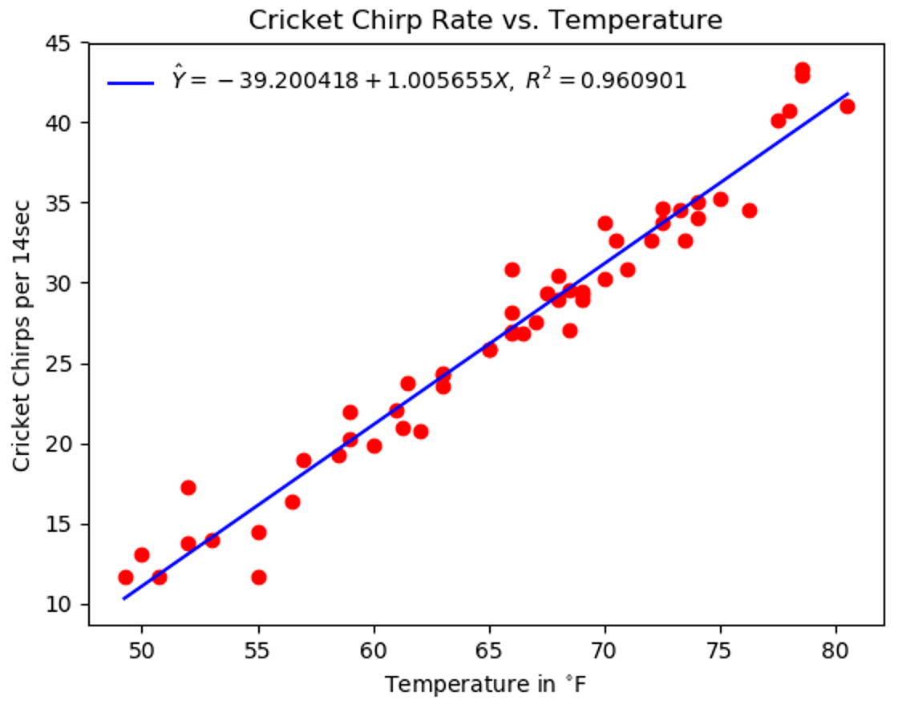Figure 2: Cricket chirps vs. temperature, with fitted model
Given that fitting statistical models (linear or otherwise) to data is a common task in scientific computing, decision sciences, etc., we would expect to find this functionality in some 3rd-party Python libraries. In fact, SciPy—one of the most widely used Python libraries for scientific and engineering applications—includes functions for performing regression analysis.
We can easily replace our regression code with in invocation of the scipy.stats.linregress function, with a few changes to the simple_linear.py file.

Import linregress
First, let’s tell Python that we want to use the linregress function. To do this, add the following line near the top of the file. (In general, import statements are found in the first non-blank, non-comment lines of a Python file.)
from scipy.stats import linregress
Listing 6: Importing scipy.stats.linregress in simple_linear.py

Estimate parameters, compute R² and fitted values
The linregress function returns the values of a and b, as well as the correlation coefficient (which can be squared to get the coefficient of determination)—along with some other values that we won’t be using (for now). Essentially, we can replace our _compute_sums, _estimate_parameters, and _measure_fit methods with an invocation of linregress, plus a couple more lines of code. So we might as well put this code in the SimpleLinear.regress method:
def regress(self):
"""Perform least squares regression on data."""
self._slope, self._intercept, r, p, std_err = linregress(self._x, self._y)
self._r2 = r * r
fitted = [self._intercept + self._slope * x for x in self._x]
self._compute_sums()
self._estimate_parameters()
self._measure_fit()
Listing 7: Invoking linregress in SimpleLinear.regress method

Remove unused methods
Since we’re no longer invoking the _compute_sums, _estimate_parameters, and _measure_fit methods, we should remove them from the SimpleLinear class; however, this is left as an exercise for you.

Test the SciPy version
Save your changes and run chirps.py. Do you notice any changes? Should we expect any?

References
- “Cricket Chirps: Nature's Thermometer”. Retrieved Oct. 7, 2018 from http://www.almanac.com/cricket-chirps-temperature-thermometer
- M. A. LeMone. (Oct. 5, 2007). “Measuring temperature using crickets”. Retrieved Oct. 7, 2018 from https://www.globe.gov/explore-science/scientists-blog/archived-posts/sciblog/index.html_p=45.html
- John Hunter, Darren Dale, Michael Droettboom. (Sep. 21 2018). Matplotlib v3.0.0. Retrieved Oct. 9, 2018 from https://matplotlib.org

- : Cricket Chirps vs. Temperature
The following observations were recorded by Dr. Margaret LeMone in Boulder, Colorado, over a 30 day period in August and September, 2007 [2]. The measurements were originally in chirps per 30 seconds; the column for chirps per 14 seconds was derived from the original data.
Date | Time | Chirps/15s | Chirps/14s | Temp (ºF)
21 Aug | 2030 | 44 | 41.067 | 80.5
21 Aug | 2100 | 46.4 | 43.307 | 78.5
21 Aug | 2200 | 43.6 | 40.693 | 78
24 Aug | 1945 | 35 | 32.667 | 73.5
24 Aug | 2015 | 35 | 32.667 | 70.5
24 Aug | 2100 | 32.6 | 30.427 | 68
24 Aug | 2200 | 28.9 | 26.973 | 66
24 Aug | 2230 | 27.7 | 25.853 | 65
25 Aug | 0030 | 25.5 | 23.8 | 61.5
25 Aug | 0330 | 20.375 | 19.017 | 57
25 Aug | 0500 | 12.5 | 11.667 | 55
25 Aug | 2000 | 37 | 34.533 | 76.25
25 Aug | 2030 | 37.5 | 35.0 | 74
25 Aug | 2100 | 36.5 | 34.067 | 74
25 Aug | 2200 | 36.2 | 33.787 | 72.5
26 Aug | 0530 | 33 | 30.8 | 66
26 Aug | 2030 | 43 | 40.133 | 77.5
26 Aug | 2200 | 46 | 42.933 | 78.5
27 Aug | 2000 | 29 | 27.067 | 68.5
27 Aug | 2030 | 31.7 | 29.587 | 68.5
27 Aug | 2100 | 31 | 28.933 | 68
27 Aug | 2200 | 28.75 | 26.833 | 66
28 Aug | 0240 | 23.5 | 21.933 | 59
28 Aug | 2010 | 32.4 | 30.24 | 70
28 Aug | 2050 | 31 | 28.933 | 69
28 Aug | 2200 | 29.5 | 27.533 | 67
29 Aug | 0240 | 22.5 | 21.0 | 61.25
29 Aug | 0440 | 20.6 | 19.227 | 58.5
29 Aug | 2000 | 35 | 32.667 | 72
29 Aug | 2050 | 33.1 | 30.893 | 71
29 Aug | 2200 | 31.5 | 29.4 | 69
29 Aug | 2330 | 28.8 | 26.88 | 66.5
30 Aug | 0330 | 21.3 | 19.88 | 60
30 Aug | 2000 | 37.8 | 35.28 | 75
30 Aug | 2055 | 37 | 34.533 | 73.25
30 Aug | 2200 | 37.1 | 34.627 | 72.5
1 Sep | 2200 | 36.2 | 33.787 | 70
2 Sep | 0330 | 31.4 | 29.307 | 67.5
2 Sep | 0600 | 30.2 | 28.187 | 66
4 Sep | 0240 | 31.3 | 29.213 | 69
4 Sep | 0505 | 26.1 | 24.36 | 63
5 Sep | 0500 | 25.2 | 23.52 | 63
6 Sep | 0600 | 23.66 | 22.083 | 61
7 Sep | 0215 | 22.25 | 20.767 | 62
7 Sep | 0525 | 17.5 | 16.333 | 56.5
9 Sep | 2010 | 15.5 | 14.467 | 55
9 Sep | 2110 | 14.75 | 13.767 | 52
10 Sep | 2115 | 15 | 14.0 | 53
10 Sep | 2210 | 14 | 13.067 | 50
11 Sep | 0315 | 18.5 | 17.267 | 52
16 Sep | 2100 | 27.7 | 25.853 | 65
17 Sep | 2200 | 26 | 24.267 | 63
18 Sep | 0130 | 21.7 | 20.253 | 59
19 Sep | 0415 | 12.5 | 11.667 | 50.75
19 Sep | 0435 | 12.5 | 11.667 | 49.25

Figure 3: Cricket Chirps vs. Temperature
- : Python Implementation of Simple Linear Regression
All comments and docstrings have been omitted from these code listings, and any occurrence of multiple consecutive blank lines has been collapsed into a single line.
1  2  3  4  5  6  7  8  9  10  11  12  13  14  15  16  17  18  19  20  21  22  23  24  25  26  27  28  29  30  31  32  33  34  35  36  37  38  39  40  41  42  43  44 | import sys  import matplotlib.pyplot as pyplot  from parser_util import TableFileParser  from simple_linear import SimpleLinear  DEFAULT_DATA_FILE = "chirps.csv"  DEFAULT_DELIMITER = ","  DEFAULT_SKIP_LINES = 1  CHART_TITLE = "Cricket Chirp Rate vs. Temperature"  X_AXIS_TITLE = "Temperature in $^{\circ}$F"  Y_AXIS_TITLE = "Cricket Chirps per 14sec"  MODEL_SPEC = "$\hat{Y} = %8.6f + %8.6fX, \; R^2 = %8.6f$"  def load(args):  default_params = [DEFAULT_DATA_FILE, DEFAULT_DELIMITER, DEFAULT_SKIP_LINES]  data_file, delimiter, skip = map(lambda default, actual:  actual if actual is not None else default,  default_params, args)[:3]  observations = TableFileParser(data_file, delimiter, skip).floats()  x, y = zip(*observations)  return (x, y)  def plot(model):  pyplot.title(CHART_TITLE)  pyplot.xlabel(X_AXIS_TITLE)  pyplot.ylabel(Y_AXIS_TITLE)  pyplot.plot(model.x, model.y, marker='o', linestyle='None', color='red')  if model.r2 >= 0:  x_bounds = (min(model.x), max(model.x))  y_fit = [model.intercept + model.slope * x for x in x_bounds]  fit, = pyplot.plot(x_bounds, y_fit, marker='None', linestyle='-',  color='blue')  pyplot.legend([fit],  [MODEL_SPEC % (model.intercept, model.slope, model.r2)],  loc='upper left', frameon=False)  pyplot.show()  if __name__ == "__main__":  x, y = load((sys.argv + [None] * 3)[1:4])  model = SimpleLinear(x, y)  model.regress()  plot(model)
Listing 8: chirps.py

1  2  3  4  5  6  7  8  9  10  11  12  13  14  15  16  17  18  19  20  21  22  23  24  25  26  27  28  29  30  31  32  33  34  35  36  37  38  39  40  41  42  43  44  45  46  47  48  49  50  51  52  53  54  55  56  57  58  59 | class SimpleLinear(object):  def __init__(self, x, y):  self._n = len(x)  self._x = tuple(x)  self._y = tuple(y)  self._intercept = 0  self._slope = 0  self._r2 = -1  def regress(self):  self._compute_sums()  self._estimate_parameters()  self._measure_fit()  @property  def n(self):  return self._n  @property  def x(self):  return self._x  @property  def y(self):  return self._y  @property  def intercept(self):  return self._intercept  @property  def slope(self):  return self._slope  @property  def r2(self):  return self._r2  def _compute_sums(self):  self._sum_x = sum(self._x)  self._sum_y = sum(self._y)  self._sum_xy = sum(map(lambda x, y: x * y, self._x, self._y))  self._sum_x2 = sum(x * x for x in self._x)  self._sum_y2 = sum(y * y for y in self._y)  def _estimate_parameters(self):  self._intercept = (  (self._sum_x2 * self._sum_y - self._sum_x * self._sum_xy)  / (self._n * self._sum_x2 - self._sum_x * self._sum_x))  self._slope = (  (self._n * self._sum_xy - self._sum_x * self._sum_y)  / (self._n * self._sum_x2 - self._sum_x * self._sum_x))  def _measure_fit(self):  fitted = [self._intercept + self._slope * x for x in self._x]  sst = self._sum_y2 - self._sum_y * self._sum_y / self._n;  sse = sum(map(lambda y, y_hat: (y - y_hat) ** 2, self._y, fitted))  self._r2 = 1 - sse / sst
Listing 9: simple_linear.py

1  2  3  4  5  6  7  8  9  10  11  12  13  14  15  16  17  18  19  20  21  22  23  24  25  26  27  28  29  30  31  32  33  34  35  36  37  38  39  40  41 | from scipy.stats import linregress  class SimpleLinear(object):  def __init__(self, x, y):  self._n = len(x)  self._x = tuple(x)  self._y = tuple(y)  self._intercept = 0  self._slope = 0  self._r2 = -1  def regress(self):  self._slope, self._intercept, r, p, std_err = linregress(  self._x, self._y)  self._r2 = r * r  fitted = [self._intercept + self._slope * x for x in self._x]  @property  def n(self):  return self._n  @property  def x(self):  return self._x  @property  def y(self):  return self._y  @property  def intercept(self):  return self._intercept  @property  def slope(self):  return self._slope  @property  def r2(self):  return self._r2
Listing 10: simple_linear.py (using SciPy)

1  2  3  4  5  6  7  8  9  10  11  12  13  14  15  16  17 | class TableFileParser(object):  def __init__(self, file_name, delimiter, skip=0):  specified file and parsing them into a list of string lists."""  with open(file_name) as file:  table = [line.strip().split(delimiter) for line in file  if 0 != len(line.strip())]  self._table = table[skip:]  def strings(self):  return [row[:] for row in self._table]  def ints(self):  return [[int(col) for col in row] for row in self._table]  def floats(self):  return [[float(col) for col in row] for row in self._table]
Listing 11: parser_util.py

Acknowledgements
These materials, and the accompanying Python code, were written with the invaluable editorial and creative assistance of L.D. Landis, Drew Einhorn, and Joel Castellanos.

Python also supports the definition and use of class methods and static methods and data. These are associated with the class as a whole, and not with instances of a class; self isn't a parameter for class or static methods.

